Practical 6

Problem Definition

You’re optimizing an existing JavaScript application by adding

functionality without modifying original constructors. Use the prototype

property to add a method to built-in Array or String constructors.

Code

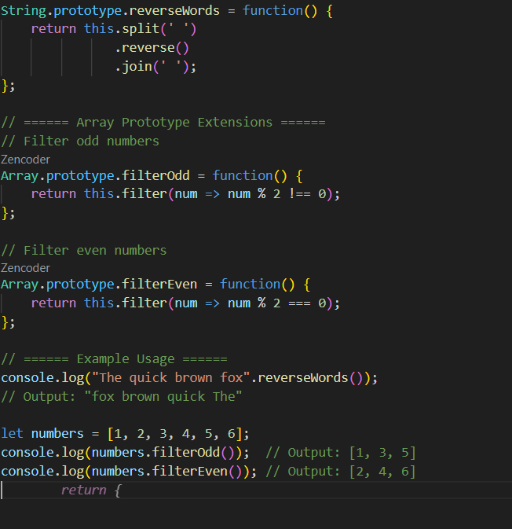

Output:

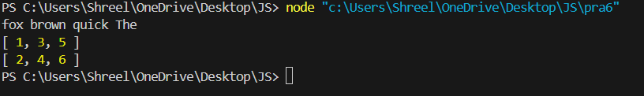

Practical 7

Problem Definition Develop a calculator module that encapsulates arithmetic operations. Export the class and import it into another module for execution. Key Questions to be evaluated during/after Implementation

Code

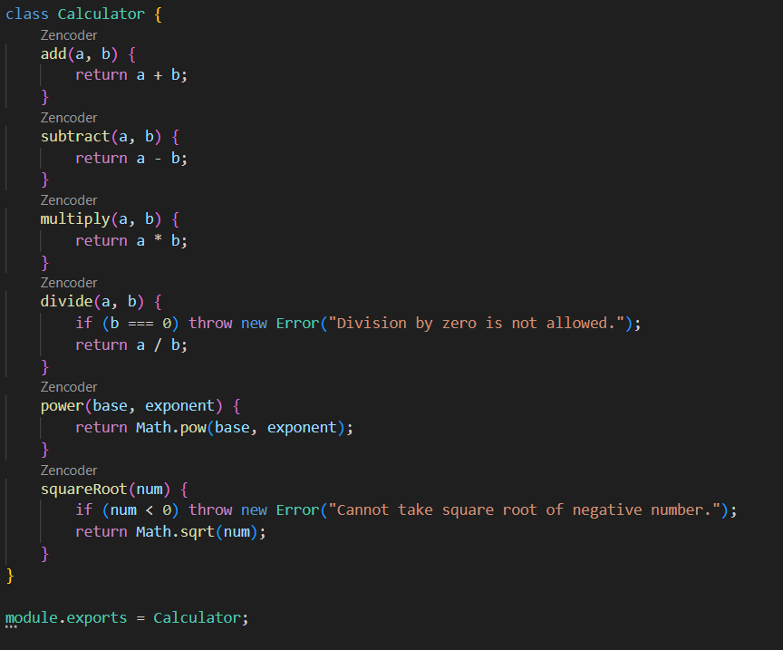

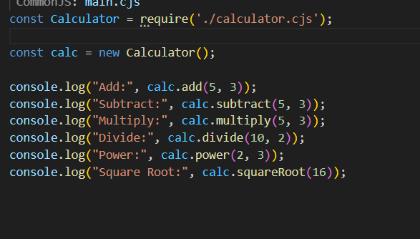

Output”

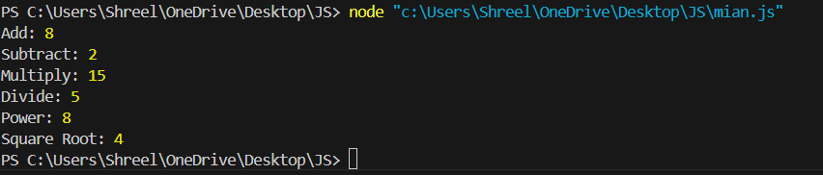

Practical 8

Problem Definition

You are tasked with building a GitHub profile viewer that fetches user data asynchronously using the fetch API. Handle multiple user requests and fail-safe error handling.

Code

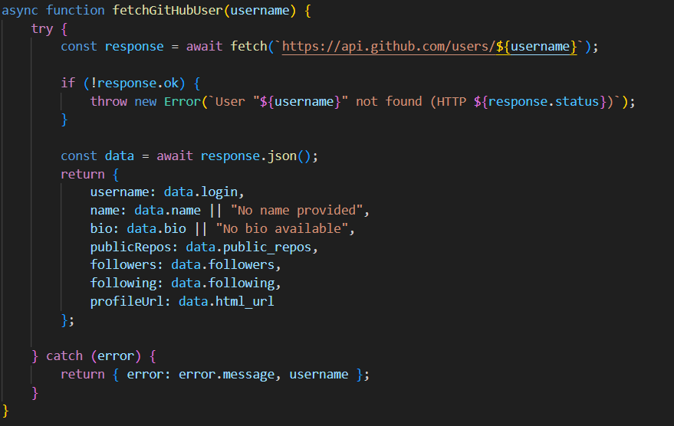

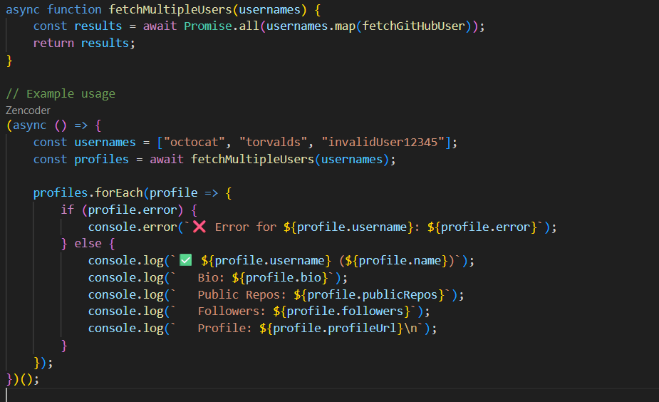

Output:

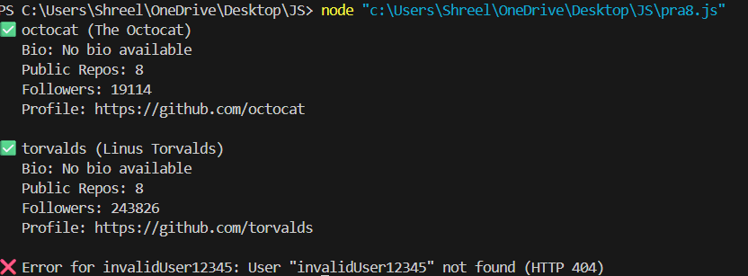

Practical 9

Problem Definition

In an e-commerce dashboard, different modules need to be loaded only when accessed (e.g., inventory vs orders). Use import() to dynamically load modules.

Code

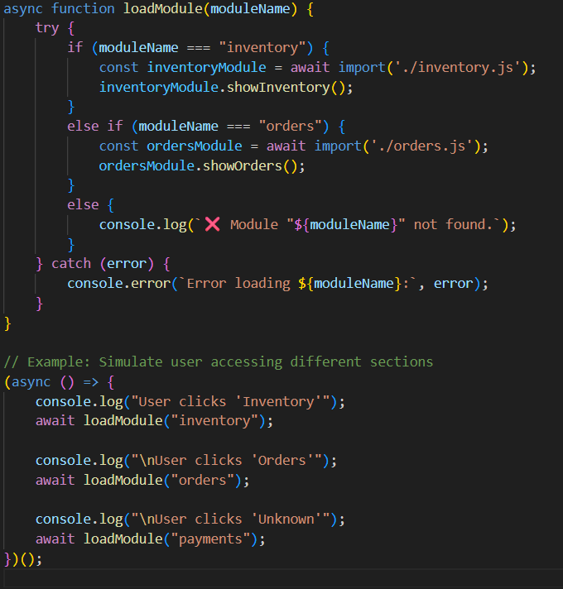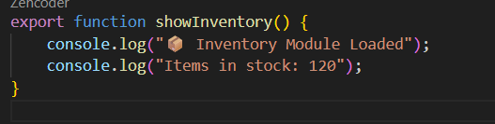

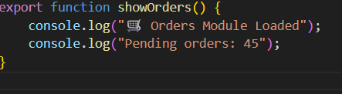

Output:

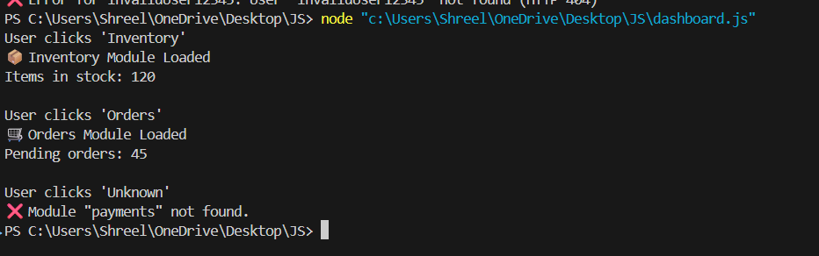

Practical 10

Problem Definition

You are developing a data processing engine. Use an iterator to generate

an infinite number sequence and a generator to produce even numbers.

Code

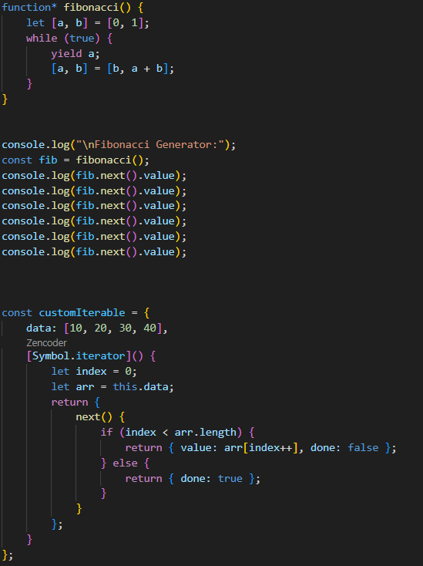

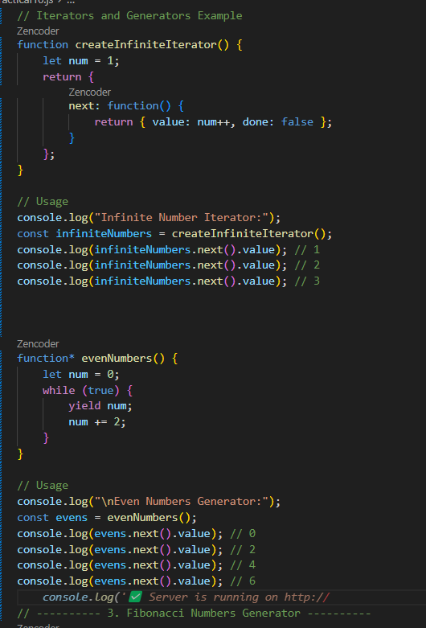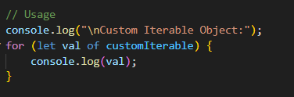

Output: 